OCEANEXT Conference, 3-5 July 2019, Nantes (France)
https://oceanext-2019.sciencesconf.org/

Special session “Questioning and sharing innovation in Higher Education on Marine Spatial Planning”

Organizers: ERASMUS+ Strategic Partnership on Higher Education in MSP (http://www.msp-education.eu) and Marine Spatial Planning Research Network (https://www.msprn.net/home)

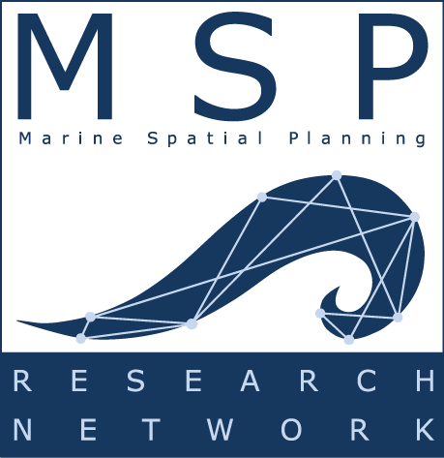

Abstract:
Marine Spatial Planning (MSP) is increasingly expanding throughout the world. MSP also require innovations able to renew ways of thinking, practices and methodologies when qualifying researchers and professionals. Education on MSP needs to focus, e.g., improving participation, facing data issues and reinvesting questions such as the role of marine spaces and places. This special session aims to shift the scope of MSP discussions to higher education by placing them under the view of methodological and didactical innovations. It is then conceived as a room for discussions about innovations in or about MSP in the nexus of education, research and practice.
Contributions are thus expected in the following topics:
- The meaning of innovation in MSP,
- Innovations in MSP education driven by research and practice,
- Innovations between education programs, disciplines and practices (in a comparative way).
These topics can also be viewed in a transversal way, in order to underline synergies and cross-fertilization. Any other proposition is welcomed as far as it concerns innovations in higher education on MSP.

The session will get stimulus from introduction to results and services of the ERASMUS+ Strategic Partnership on Higher Education in MSP.

Keynote speaker (tbc): Prof. Igor Mayer (https://pure.buas.nl/en/persons/igor-mayer-dr), Breda University of Applied Science (NL)

Details:
Abstracts submission deadline: March 1st
Notification of acceptance: March 30th
Registration and fee payment:
- Early bird registration deadline: From January 25th to April 30th
- Late registration deadline: June 15th
Final article submission: July 30th (Special edition in IOP Conference series: Earth and Environmental Science or Advances in Climate Change Research)

