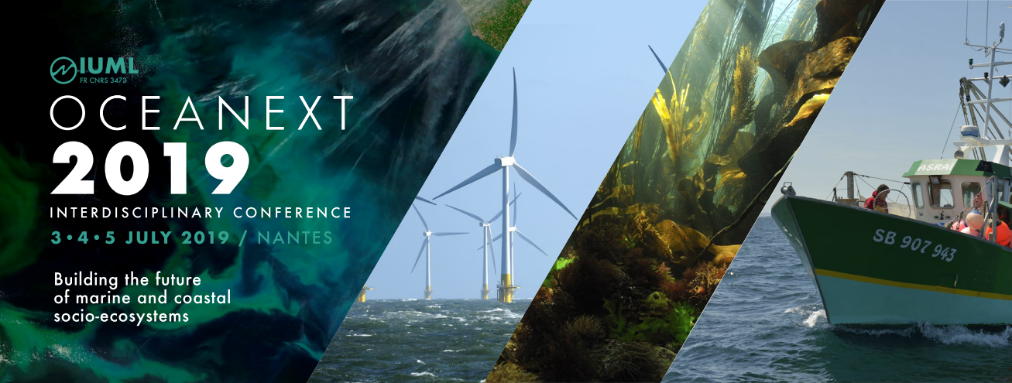

Dr. Grit Martinez
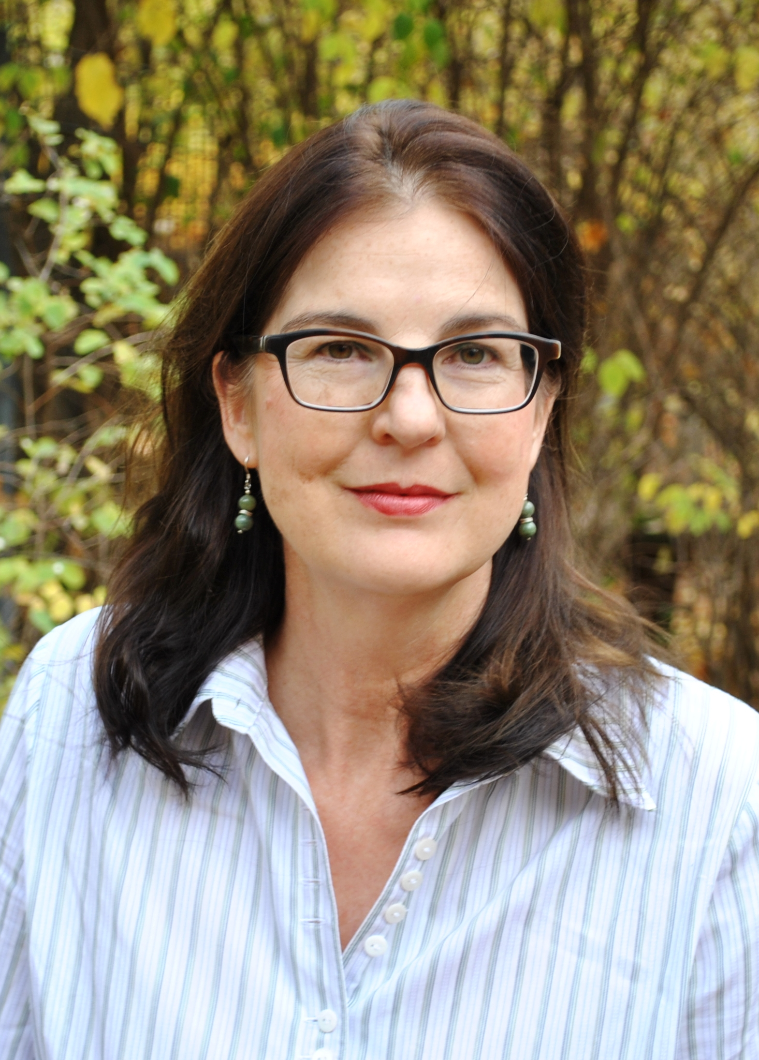
Senior Fellow at Ecologic Institute in Berlin &
Ass. Research Professor in Anthropologie at
University of Maryland, U.S.

Dr. Grit Martinez has academic roots in environmental history, linguistics and economy. Her research focus is on social-ecological systems in coastal regions worldwide, especially on the influence of culture on flood risks management. She is also interested in empirical analysis about interdisciplinary collaborations amongst the social science and humanities & the natural science, engineering and life sciences. Dr. Martinez is involved in numerous European and worldwide research projects, e.g. until recently in the project Resilience Increasing Strategies for Coasts (RISK-KIT).

References
Martinez, G., Armaroli, C., Costas, S., Harley, D. M., Paolisso, M. (2017) Experiences and results from interdisciplinary collaboration: Utilizing qualitative information to formulate disaster risk reduction measures for coastal regions, Coastal Engineering, DOI: 10.1016/j.coastaleng.2017.09.010
Costas S., Ferreira, O., Martinez G. (2015) Why do we decide to live with risk at the coast? Ocean and Coastal Management, Volume 118, Part A, (pp 1-11), https://doi.org/10.1016/j.ocecoaman.2015.05.015
Martinez, G., Paolisso, J.M. (2015) Cultural Dynamics of Adaptation to Climate Change: An Example from the East Coast of the US. In: Sommer, B. (ed.): Cultural Dynamics of Climate Change and the Environment in Northern America. Climate and Culture 3. Leiden: Brill, pp.304-332. https://brill.com/abstract/book/edcoll/9789004300712/B9789004300712_014.xml
Bray, D., Martinez, G. (2015) Climate Change Lore and Its Implications for Climate Science: Post-science deliberation? Futures, Volume 66, (pp. 54–69) http://dx.doi.org/10.1016/j.futures.2014.12.003
Martinez, G., Frick, F., Gee, K. (2014) Socioeconomic and cultural issues in the planning, implementation and transfer of adaptation measures to climate change. The example of two communities on the German Baltic Sea Coast pp 203-219, In: Martinez, G., Froehle, P., Meier, H.-J. (eds.): Social dimension of climate change adaptation in coastal regions, volume 5, München: oekom
Bray, D., Martinez, G. (2012) A survey of the perceptions of regional political decision makers concerning climate change and adaptation in the German Baltic Sea region, International BALTEX Secretariat. ISSN 1681-6471, Publication No. 50.
Abstract
Recent and historic high-impact events have demonstrated significant flood risks to many coastal areas in Europe. These risks are expected to increase due to climate change and the further development of coastal regions, and thus require appropriate prevention, mitigation, and preparedness measures. Consequently, the management and communication of risks has become a major question of public policy.
It is well known that social and individual factors influence the perceptions of risk and the approaches to response. Thus, risk management is the result of social relations among people living in regions, which are characterized by the particularities of history, values and beliefs, political and legal traditions, economic resources, concepts of justice, interpretations of responsibilities, and structures of risk governance and others. Europe’s cultural heterogeneity and diversity offer rich materials for studying various risk management cultures and their implications for the execution of measures.
The keynote will address aspects of coastal risk management in relation to the socio-cultural context in various coastal regions, drawing on case studies from Europe and beyond. The keynote will also elaborate on the need for interdisciplinary collaboration among the social science & humanities and the natural sciences, engineering & life sciences by referring to empirical results from such collaborations.

